

NAME : BISMA FATIMA
CLASS : CS A
ROLL NO: F24605036
COURSE : OBJECT ORIENTED PROGRAMMING
COURSE CODE : CS-123
LECTURER : MISS TAYYABA KALSOOM
POST LAB TASK
LAB 02

Task 5: Reverse a String
Write a program that takes a string as input and prints it in reverse order.

PROGRAM
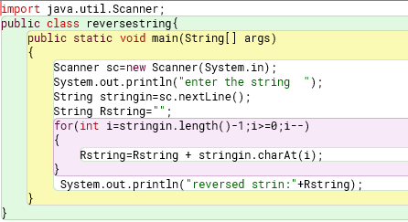

OUTPUT
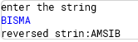

Task 6: Count Vowels and Consonants
Write a program that takes a string as input and counts the number of vowels and
consonants in it. Ignore spaces and special characters.

PROGRAM
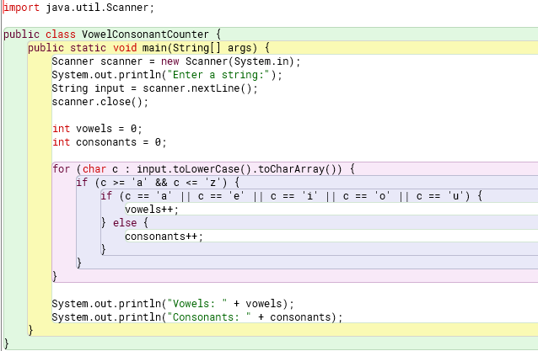

OUTPUT
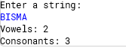

Task 7: Factorial Calculation
Write a program that calculates the factorial of a given number using a loop. For
example, if the input is 5, the output should be 120 (5 × 4 × 3 × 2 × 1).

PROGRAM
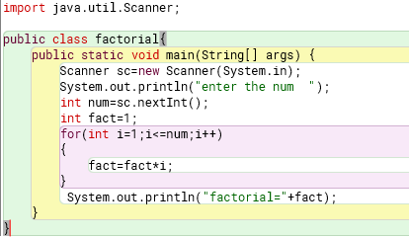

OUTPUT
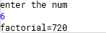

Task 8: Fibonacci Series
Write a program that generates the Fibonacci series up to a given number of terms.

PROGRAM
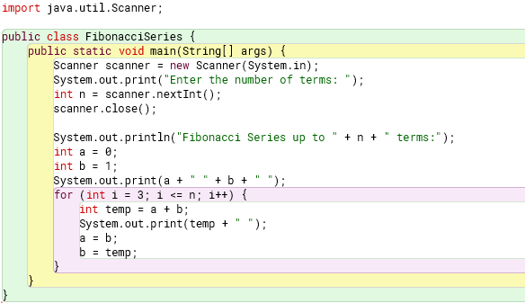

OUTPUT
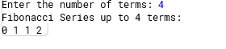

Task 9: Guess the Number
Write a program that generates a random number between 1 and 100 and asks the user to guess it. Provide feedback (”Too high” or ”Too low”) until the user guesses the correct number.
PROGRAM
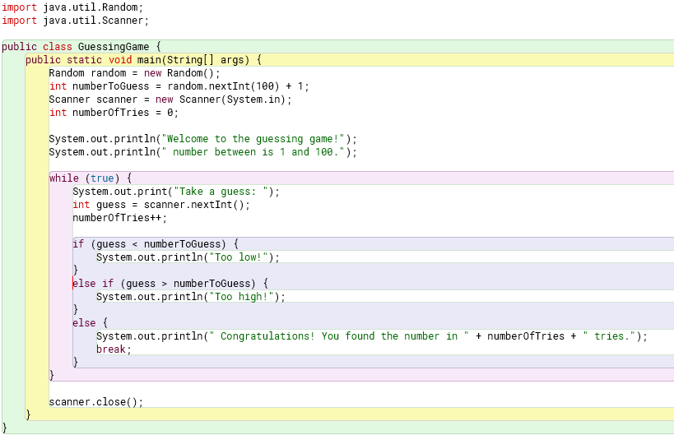

OUTPUT
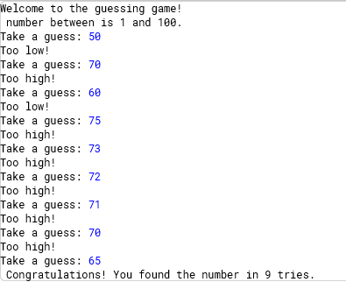
Task 10: Pattern Printing
Write a program that prints the following pattern based on user input.

PROGRAM
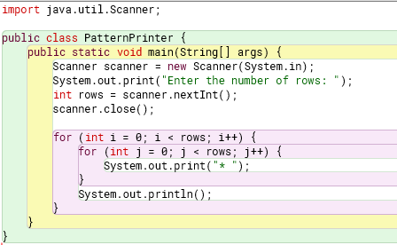

OUTPUT
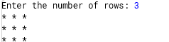

Scenario Based Task 11: Scenario
Mrs. Eleanor Vance, a retired school teacher, walks into your bank branch. She is interested in opening a fixed deposit account. She tells you she is 68 years old and wants to deposit $10,000 for one year.
At the same time, a young professional, Mr. David Crane, approaches your desk. He is 35 years old and wants to deposit $5,000 for one year in a similar fixed deposit account.
Your bank has a policy:
- Senior citizens (age 60 or more) receive a 10% annual interest rate.
- Depositors under 60 years old receive a 9% annual interest rate.

PROGRAM
1. public class interest {
2. public static void main(String[] args) {
3. // Customer data // v shows the data of mrs vance whereas d shows the data of david
4. int v_age = 68;
5. double v_principal = 10000;
6. int d_age = 35;
7. double d_principal = 5000;
8.
9. // Calculate interest rate
10. double v_interestRate, d_interestRate;
11. if (v_age >= 60) {
12. v_interestRate = 0.10;
13. } else {
14. v_interestRate = 0.09;
15. }
16. if (d_age >= 60) {
17. d_interestRate = 0.10;
18. } else {
19. d_interestRate= 0.09;
20. }
21.
22. // Add additional interest if deposit is over $15,000
23. if (v_principal > 15000) {
24. v_interestRate += 0.005;
25. }
26. if (d_principal > 15000) {
27. d_interestRate += 0.005;
28. }
29.
30. // Calculate interest
31. double v_interest = v_principal * v_interestRate;
32. double d_interest = d_principal * d_interestRate;
33.
34. // Calculate total amount
35. double v_totalAmount = v_principal + v_interest;
36. double d_totalAmount = d_principal + d_interest;
37.
38. // Print results
39. System.out.println("Customer 1 (Mrs. Vance):");
40. System.out.println("Interest Rate: " + v_interestRate * 100 + "%");
41. System.out.println("Interest: $" + v_interest);
42. System.out.println("Total Amount: $" + v_totalAmount);
43. System.out.println("\nCustomer 2 (Mr. Crane):");
44. System.out.println("Interest Rate: " + d_interestRate * 100 + "%");
45. System.out.println("Interest: $" + d_interest);
46. System.out.println("Total Amount: $" + d_totalAmount);
47.
48. }
49. }
50.

OUTPUT
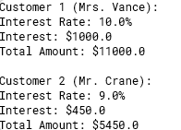

Scenario Based Task 12:
A local bakery, Sweet Delights, is preparing for its annual cupcake decorating contest. They have three types of cupcakes: Vanilla, Chocolate, and Red Velvet. Each contestant will receive a box containing a specific number of each cupcake type.
Here’s the breakdown:
- Vanilla: 5 cupcakes per contestant
- Chocolate: 3 cupcakes per contestant
- Red Velvet: 2 cupcakes per contestant
The bakery expects 10 contestants to participate.
Questions:
- Using a for loop, calculate and display the total number of Vanilla cupcakes needed for all contestants.

1. public class CupcakeCalculator {
2. public static void main(String[] args) {
3. int contestants = 10;
4. int vanillaPerContestant = 5;
5. int totalVanilla = 0;
6.
7. for (int i = 0; i < contestants; i++) {
8. totalVanilla += vanillaPerContestant;
9. }
10.
11. System.out.println("Total Vanilla Cupcakes Needed: " + totalVanilla);
12. }
13. }

2. Modify the loop to also calculate and display the total number of Chocolate and Red Velvet cupcakes needed.
1. public class CupcakeCalculator {
2. public static void main(String[] args) {
3. int contestants = 10;
4. int chocolatePerContestant = 3;
5. int redVelvetPerContestant = 2;
6. int totalVanilla = 0;
7. int totalChocolate = 0;
8. int totalRedVelvet = 0;
9.
10. for (int i = 0; i < contestants; i++) {
11. totalChocolate += chocolatePerContestant;
12. totalRedVelvet += redVelvetPerContestant;
13. }
14.
15. System.out.println("Total Chocolate Cupcakes Needed: " + totalChocolate);
16. System.out.println("Total Red Velvet Cupcakes Needed: " + totalRedVelvet);
17. }
18. }

3. The bakery decides to add a Mystery Flavor and gives 1 mystery cupcake to each contestant. Modify your existing loop to also calculate the total of mystery flavor cupcakes.
1. public class CupcakeCalculator {
2. public static void main(String[] args) {
3. int contestants = 10;
4. int vanillaPerContestant = 5;
5. int chocolatePerContestant = 3;
6. int redVelvetPerContestant = 2;
7. int mysteryPerContestant = 1;
8. int totalVanilla = 0;
9. int totalChocolate = 0;
10. int totalRedVelvet = 0;
11. int totalMystery = 0;
12.
13. for (int i = 0; i < contestants; i++) {
14. totalVanilla += vanillaPerContestant;
15. totalChocolate += chocolatePerContestant;
16. totalRedVelvet += redVelvetPerContestant;
17. totalMystery += mysteryPerContestant;
18. }
19.
20. System.out.println("Total Vanilla Cupcakes Needed: " + totalVanilla);
21. System.out.println("Total Chocolate Cupcakes Needed: " + totalChocolate);
22. System.out.println("Total Red Velvet Cupcakes Needed: " + totalRedVelvet);
23. System.out.println("Total Mystery Cupcakes Needed: " + totalMystery);
24. }
25. }

4. If the bakery wants to print a list showing the number of each cupcake type each contestant gets, how would you use a nested loop to achieve this? (e.g., Contestant 1: 5 Vanilla, 3 Chocolate, 2 Red Velvet, 1 Mystery).
1. public class CupcakeCalculator {
2. public static void main(String[] args) {
3. int contestants = 10;
4. int vanillaPerContestant = 5;
5. int chocolatePerContestant = 3;
6. int redVelvetPerContestant = 2;
7. int mysteryPerContestant = 1;
8.
9. for (int i = 1; i <= contestants; i++) {
10. System.out.println("Contestant " + i + ":");
11. System.out.println(vanillaPerContestant + " Vanilla Cupcakes");
12. System.out.println(chocolatePerContestant + " Chocolate Cupcakes");
13. System.out.println(redVelvetPerContestant + " Red Velvet Cupcakes");
14. System.out.println(mysteryPerContestant + " Mystery Cupcakes");
15. System.out.println();
16. }
17. }
18. }

5. Write a Java code extract that implements the logic of the first three questions.

1. public class CupcakeCalculator {
2. public static void main(String[] args) {
3. int contestants = 10;
4. int vanillaPerContestant = 5;
5. int chocolatePerContestant = 3;
6. int redVelvetPerContestant = 2;
7. int mysteryPerContestant = 1;
8. int totalVanilla = 0;
9. int totalChocolate = 0;
10. int totalRedVelvet = 0;
11. int totalMystery = 0;
12.
13. for (int i = 0; i < contestants; i++) {
14. totalVanilla += vanillaPerContestant;
15. totalChocolate += chocolatePerContestant;
16. totalRedVelvet += redVelvetPerContestant;
17. totalMystery += mysteryPerContestant;
18. }
19.
20. System.out.println("Total Vanilla Cupcakes Needed: " + totalVanilla);
21. System.out.println("Total Chocolate Cupcakes Needed: " + totalChocolate);
22. System.out.println("Total Red Velvet Cupcakes Needed: " + totalRedVelvet);
23. System.out.println("Total Mystery Cupcakes Needed: " + totalMystery);
24. }
25. }
26.

OUTPUT
